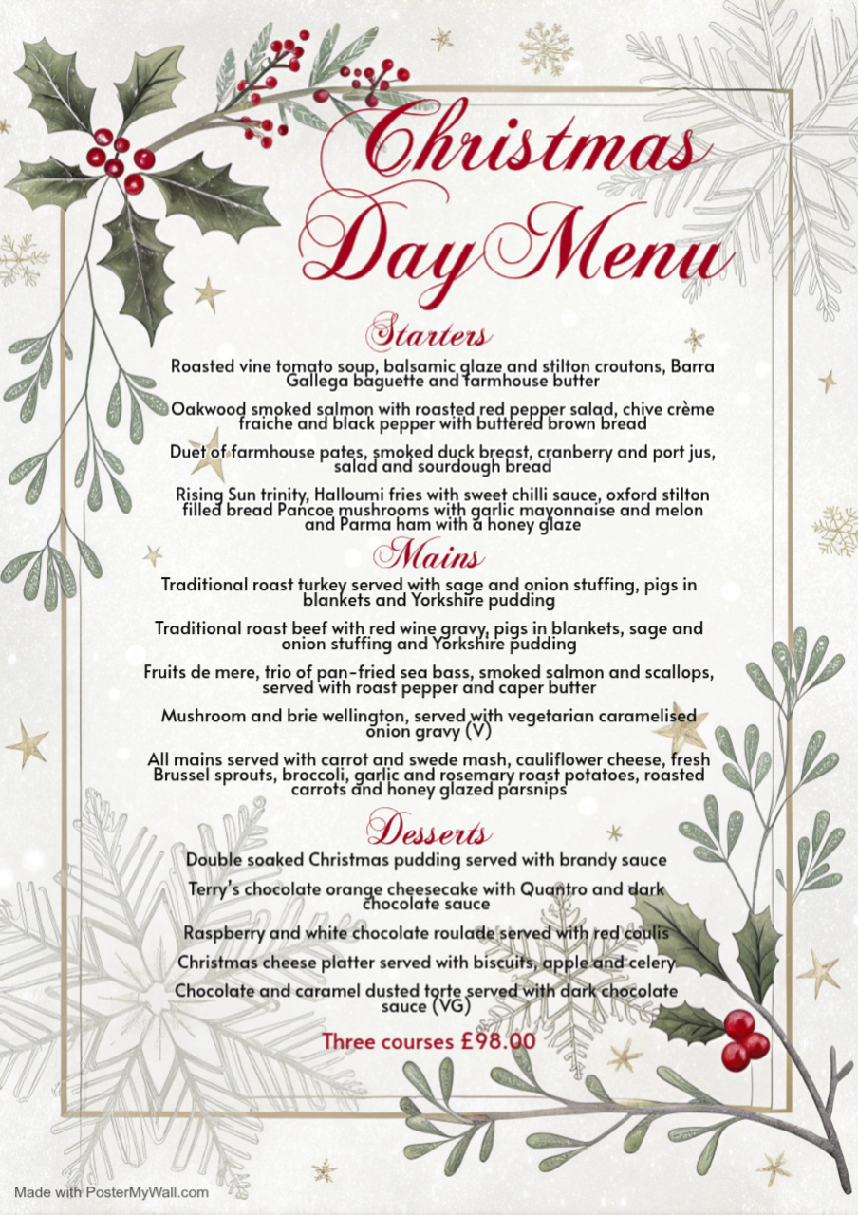
Christmas Day Menu
All meals need to be pre ordered 14 days prior to joining us.
Vegan & Vegetarian options available
All bookings require a 50% deposit, non- refundable
£45.00 for children 12 and under
Please let us know of any dietary requirements when booking.
Name ______________________ Telephone ____________________
Time ______________________ Email _____________________
Number of guests __________ Deposit paid __________________

Pre order
Starters
Soup ________
Pate ________
Smoked Salmon ________
Rising sun trinity ________
Mains
Roast Turkey ________
Roast Beef ________
Fruits de mere ________
Wellington ________
Desserts
Christmas Pudding ________
Cheesecake ________
Raspberry Roulade ________
Chocolate Torte ________
Cheese board ________

